# 

# Example of Freight Generation Execution

This section presents a step-by-step example of how to use the developed ArcGIS application.

**STEP 1**

Open newly added FTG_Tool toolbox and launch Freight Generation function (see FIGURE 1).

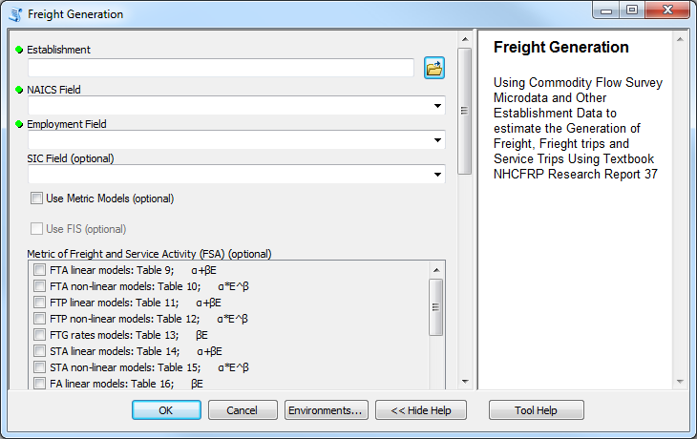Figure 1 Freight Generation Function

**STEP 2**

Input path to data feature layer into Freight Generation first input parameter Establishment(see FIGURE 2).

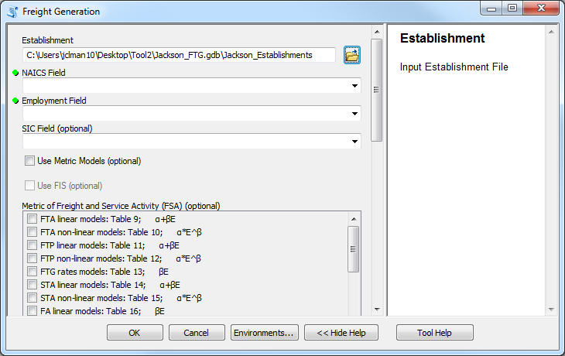

Figure 2 Input Establishment Feature Layer

**STEP 3**

Select NAICS Field from Input Parameter Establishments(see FIGURE 3).

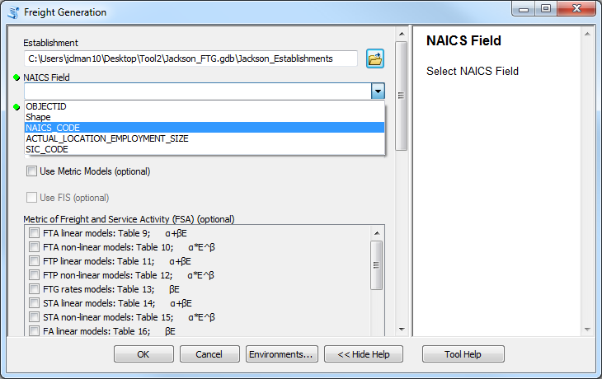

Figure 3 Select NAICS Field

**STEP 4**

Select Employment Field from input parameter Establishments (see FIGURE 4).

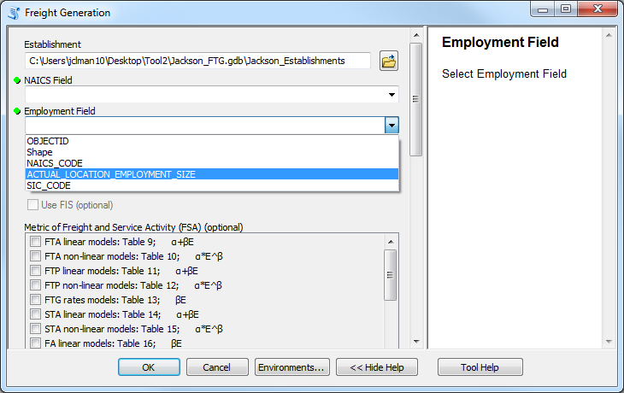

Figure 4 Select Employment Field

**STEP 5 (optional)**

Select SIC Field from input parameter Establishments (see FIGURE 5).

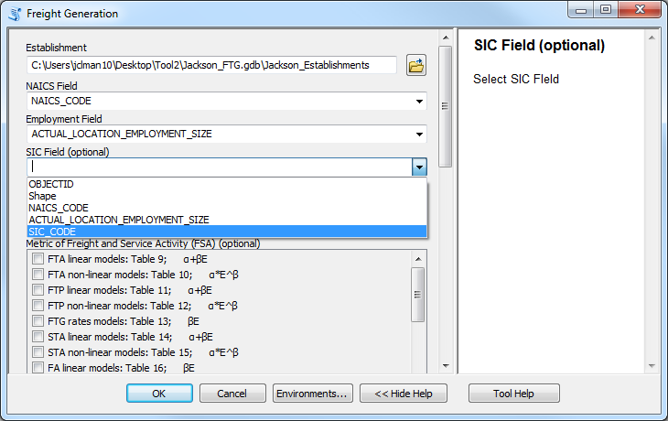

Figure 5 Select SIC Field

**STEP 6**

Select whether Metric Models will be used for the calculation. (see FIGURE 6).

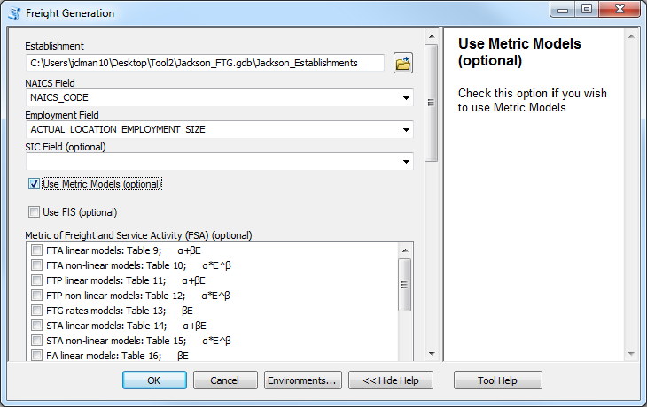

Figure 6 Select Metric Models

**STEP 7**

Select the option to use each table’s ALL Freight Sector row and fill in missing NAICS codes. (see FIGURE 7).

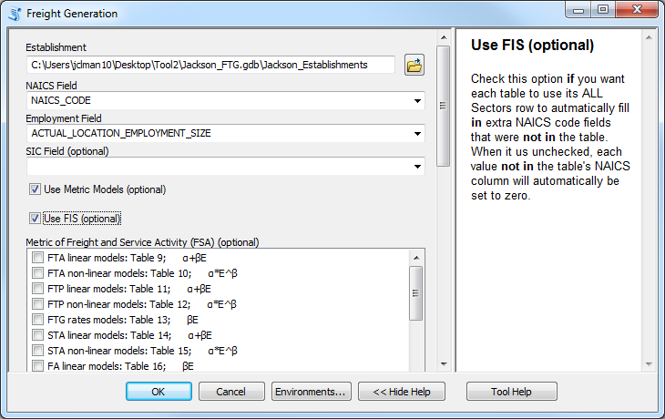

Figure 7 Select ALL Freight Modes

**STEP 8**

Select which Metric Tables to use. (see FIGURE 8).

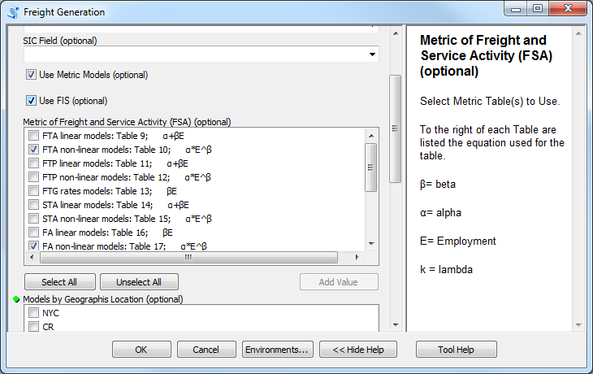

Figure 8 Select Metric Tables(s)

**STEP 9**

Select Geographic Models to Use for the Metric Tables (see FIGURE 10).

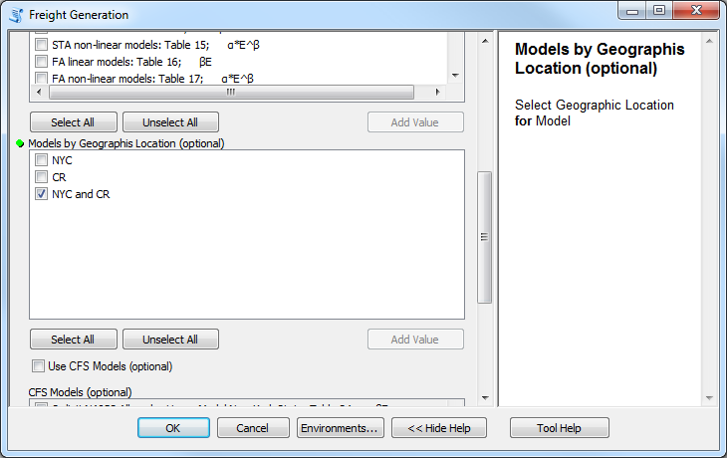

Figure 9 Select Metric Geographic Model(s)

**STEP 10**

Select Whether CFS Values will be used for the Calculations. (see FIGURE 11).

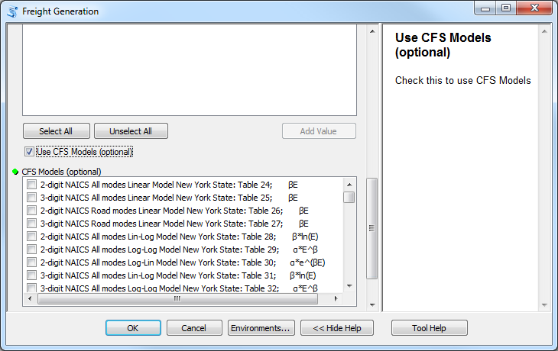

Figure 10 Select CFS Models

**STEP 11**

Select CFS Model(s). (see FIGURE 11).

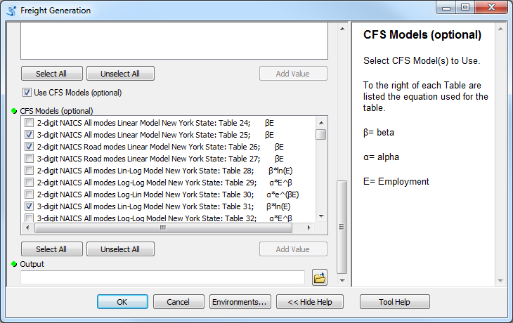

Figure 11 Select Geographical Location(s)

**STEP 12**

In toolbox Output parameter, input output folder path where processed shapefiles will be exported after toolbox analysis (see FIGURE 12).

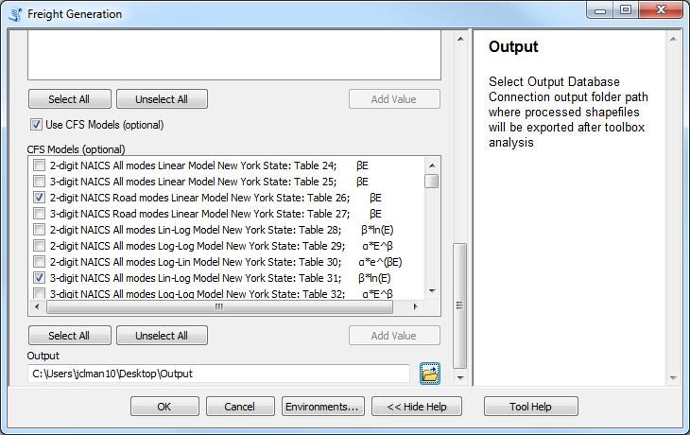

Figure 12 Input Output Folder

**STEP 13**

Once all required parameters are inputted, press OK to execute the application. The ArcGIS application invokes a task completion window, which reports status of each task (see 13). In addition, processed shapefiles will be imported to ArcMap Display (see Figure 14). The Table can be viewed in the ArcMap Output Display (see Figure 15)

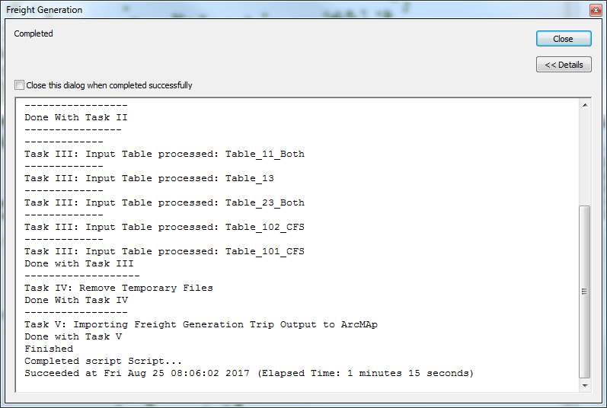

Figure 13 Application Performed Task Window

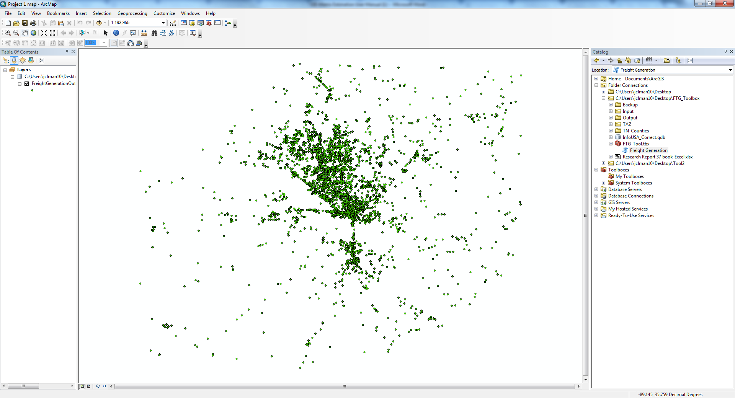

Figure 14 Displayed Process File

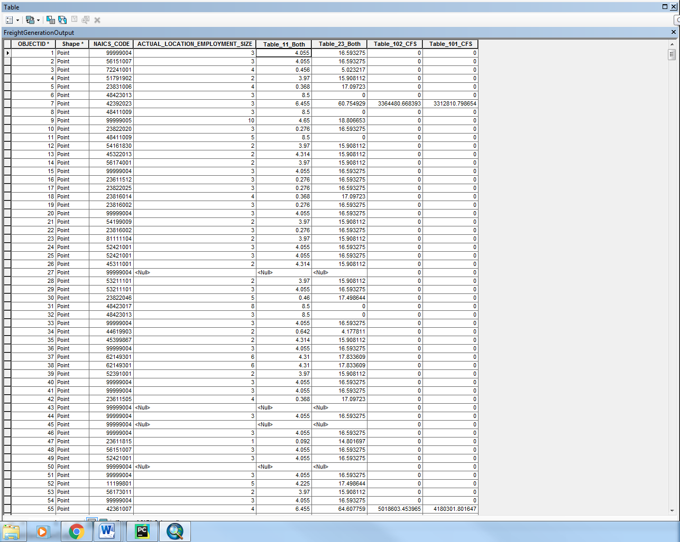

Figure 15 Displayed Table Results